**Taller Pre bimestral**

**Name: ___________________________________________________________________**

**Grade: Fourth Date: _______________________**

**Review of the topics.**

1. **Match the words with the pictures.**
2. **Library**: "I like to read books at the library."
3. **Grocery Store**: "We buy food at the grocery store."
4. **Park**: "I play with my friends at the park."
5. 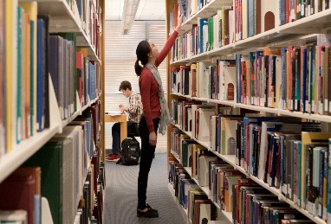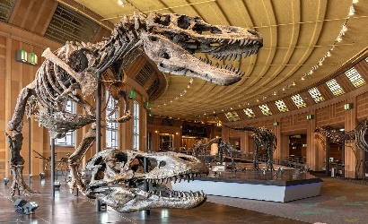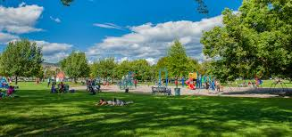**Museum**: "I see interesting things at the museum."

______ ________ ______ _______

1. **Look for these words and write them in Spanish**

Dirty:

Noisy:

Clean:

Eco-friendly:

Busy:

Crowded:

Hot:

Dry:

Buildings:

Green city:

Billboards:

Solar panels:

Paintings:

Lights:

Parks

Full of:

Cars:

Trash:

Travel:

People:

Car:

Bus:

Bicycle:

Train:

Boring:

Exciting:

Quiet:

Slow:

Dull:

Fast:

Fun:

Empty:

Dangerous:

Sad:

Tired:

Happy:

Angry: